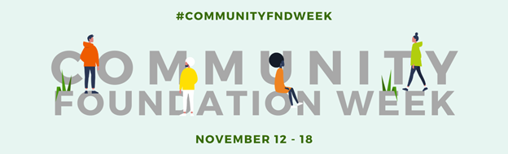

SAMPLE SOCIAL CONTENT FOR COMMUNITY FOUNDATION WEEK
Engaging your social media audience is a great way to boost awareness of Community Foundation Week. We’ve prepared some sample posts that you can share with followers to celebrate the impact of local philanthropy. Here are a few tips to consider:
- Photos and videos improve engagement on social media, especially content that reflects your organization’s work and community impact.
- Community Foundation Week graphics are available to use in your posts. Visit cof.org/cfweek to download digital assets.
- Be sure to use #CommunityFNDWeek in your posts to help amplify the collective voice of community foundations.
Questions? Contact the Council on Foundations for more information: cofcommunications@cof.org.
Promotional Social Content to Use Before November 12:
- The Council on Foundations is always proud to support local philanthropy, but especially during Community Foundation Week (November 12-18). Will you join us as we celebrate the unique ways that community foundations empower positive social change? Learn more at http://cof.org/cfweek.

- Are you ready for Community Foundation Week? This annual celebration of local philanthropy was created in 1989 by former president George H.W. Bush. From November 12-18, join the Council in recognizing the impact of community foundations across the country. Learn more: http://cof.org/cfweek
Promotional Social Content to Use Between November 12-18:
Facebook and LinkedIn
- Happy Community Foundation Week! We’re celebrating the impact of our foundation and hundreds of others across the country that are empowering positive social change in neighborhoods, counties, and states. Learn more at [link].

- We’re proud to be one of hundreds of community foundations across the country creating social change hand in hand with nonprofits. Join us in celebrating Community Foundation Week (November 12-18) to recognize the powerful impact of local philanthropy.

- We’re excited to join the national network of community foundations recognizing National Philanthropy Day and Community Foundation Week! To celebrate, we’re sharing some favorite pictures of our work over the last year. Which one is your favorite? [attach 2-4 photos]

- Community Foundation Week isn’t just about us! Which nonprofit organizations have you worked with to help deepen the impact of your local philanthropy? Tag your favorite nonprofit partner in the replies and share what you love about collaborating with them.
Twitter
The official hashtag for Community Foundation Week is #CommunityFNDWeek. Make sure to include the hashtag in your tweets, and if you are tweeting on a specific topic, use the relevant hashtags to gain more visibility. For example, if you are tweeting on education, including #education can help more people see your tweet.
- We’ve been working on [program area] in [community name] for [X] years to help our community thrive and grow. Celebrate #CommunityFNDWeek with us now and National Philanthropy Day on Nov. 15!

- To celebrate #CommunityFNDWeek, contact our charitable giving team at XXX to chat about our work on [topic area] and how we can partner with you to make it better.

- It’s the best week of the year - #CommunityFNDWeek! In the replies, share something you did this past year to make a difference or nurture connection in your community.

- Help us celebrate our local impact during #CommunityFNDWeek! We love to support [community name] and this year, we partnered with [nonprofit partner 1] to make it happen. Tag a partner you appreciate!

