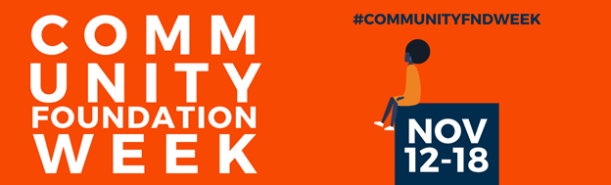
INSERT LOGO HERE

WHAT IS A COMMUNITY FOUNDATION?
A community foundation can be defined simply as a grantmaking public charity dedicated to improving the lives of people in a defined local geographic. Increasingly, however, larger community foundations are funding global initiatives, in addition to programs in their geographic region.
WHAT IS COMMUNITY FOUNDATION WEEK?
Community Foundation Week, created in 1989 by former President George H.W. Bush, recognizes the important work of community foundations throughout America and their collaborative and innovative approach to working with the public, private, and nonprofit sector. Community Foundation Week is November 12-18.
COMMUNITY FOUNDATIONS
“DID YOU KNOW”

- Many community foundations throughout the country were first responders during the COVID-19 pandemic through the creation of Response Funds. These funds were established to tackle the immediate needs of local organizations and communities that the crisis had impacted.
- Community foundations play a key role in creating more just and equitable communities. This includes establishing and supporting grantmaking, advocacy and special initiatives designed to address inequities and increase opportunities for marginalized populations to thrive and reach their full potential.
- Beyond grantmaking, community foundations also play important roles as community leaders with deep local relationships, knowledge of local challenges and opportunities, and the ability to advocate for policies that improve the quality of life in their communities.
FACTS ABOUT
COMMUNITY FOUNDATIONS

- The first community foundation was created in 1914 in Cleveland, Ohio, and operates now as the Cleveland Foundation.
- Community foundations play a key role in identifying and solving community problems. Currently, more than 750 community foundations operate in urban and rural areas in every state in the United States.
- Every continent but Antarctica has a community foundation. It’s estimated that there are at least 1,200 community foundations outside of the United States and Canada.
- According to the National Philanthropic Trust's 2020 Donor-Advised Fund Report, grantmaking from DAFs to qualified charities totaled more than $25 billion in 2019, a 93 percent increase since 2015. ¹
- Nearly every type of gift, from cash to real estate, stock, and other assets, can be donated to a community foundation.¹

